Experiment -1

<!DOCTYPE html>
<html>
<head>
<title>B.Tech Computer Science - Course Curriculum (2025-2029)</title>
</head>
<body>
<center><h1>B.Tech Computer Science - Course Curriculum</h1>
<b>Session:</b> 2025-2029 © ABES Engineering College, Ghaziabad</center>
<hr>

<section>
<h2>Introduction</h2>
<p>
The <b>Bachelor of Technology in Computer Science</b> is designed to provide students with strong foundations in computer science, software engineering, and <u>emerging technologies</u>.
</p>
</section>

<section>
<h2>Semester 1 Subjects(Ordered List)</h2>
<ol>
<li>Mathematics-I</li>
<li>Physics</li>
<li>Basic Electrical Engineering</li>
<li>Programming in C</li>
<li>Engineering Drawing</li>
<li>Web Designing Workshop-1</li>
<li>Essential of AI</li>
</ol>
</section>

<section>
<h2>Programming Languages Covered(Unordered List)</h2>
<ul>
<li>C</li>
<li>C++</li>
<li>Java</li>
<li>Python</li>
<li>JavaScript</li>
</ul>
</section>

<section>
<h2>Key Terms(Description List)</h2>
<dl>
<dt><b>AI</b></dt>
<dd>-Artificial Intelligence, the study of intelligent machines.</dd>
<dt><b>DBMS</b></dt>
<dd>-Database Management System, software to handle databases.</dd>
<dt><b>OS</b></dt>
<dd>-Operating System, software managing hardware resources.</dd>
</dl>
</section>

<section>
<h2>Elective Subjects(Nested List)</h2>
<ul>
<li>
Artificial Intelligence
<ol>
<li>Machine Learning</li>
<li>Deep Learning</li>
</ol>
</li>
<li>
Data Science
<ol>
<li>Statistics</li>
<li>Data Visualization</li>
</ol>
</li>
</ul>
</section>

<section>
<h2>Lab Curriculum(Mixed List)</h2>
<ol>
<li>
Programming Labs
<ul>
<li>C Lab</li>
<li>Python Lab</li>
</ul>
</li>
<li>
Electronics Labs
<ul>
<li>Digital Electronics Lab</li>
<li>Microprocessor Lab</li>
</ul>
</li>
</ol>
</section>
<hr>
<section>
<p align="center">© 2025 Curriculum Design ® University of Learning</p>
</section>
</body>
</html>
Output
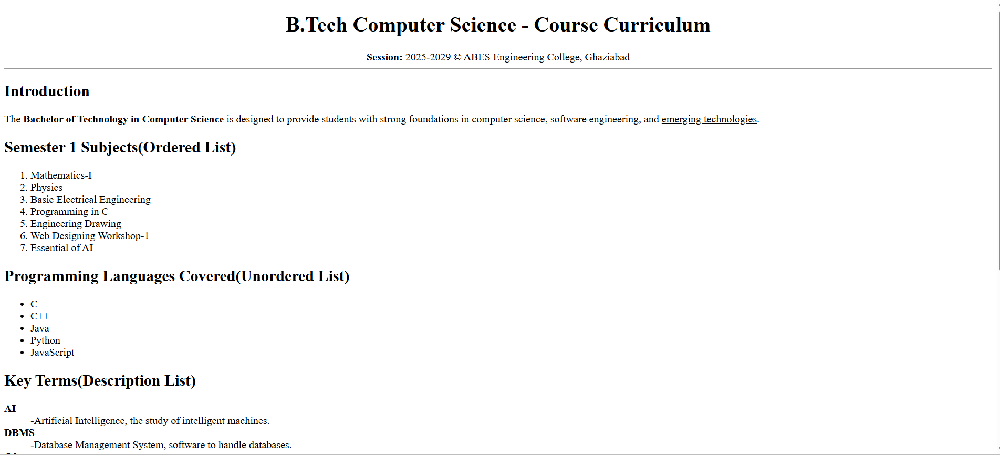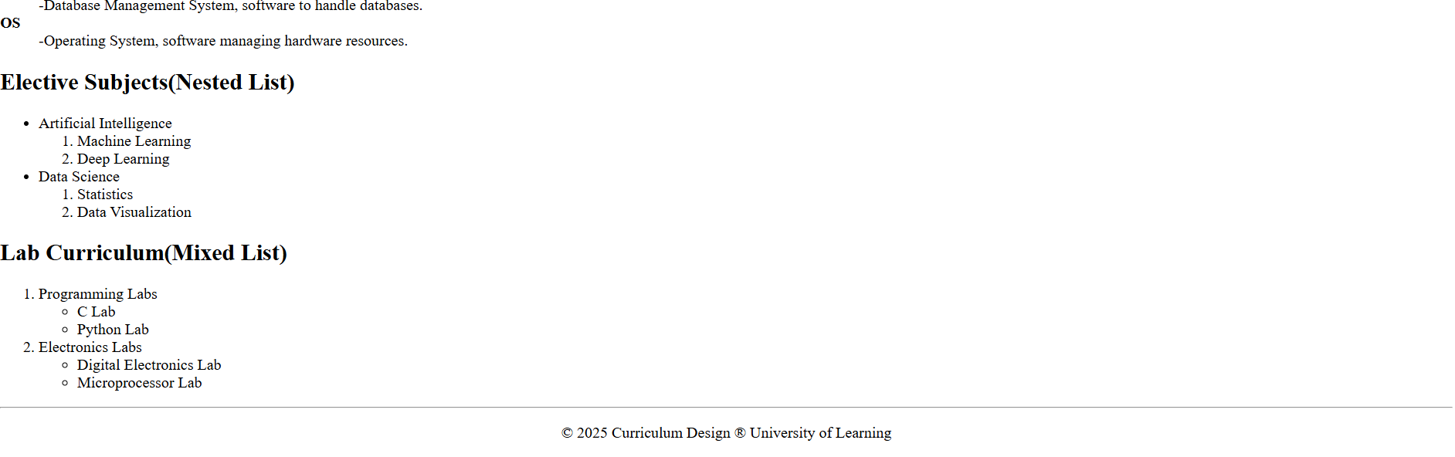

Experiment -2
<!DOCTYPE html>
<html lang="en">
<head>
<meta charset="UTF-8">
<meta name="viewport" content="width=device-width, initial-scale=1.0">
<title>Simple News Website</title>
</head>
<body>

<!--Starting Page Code -->
<h1 align="center"><u>Global Daily News</u></h1>
<p align="center">Your Trusted Source for Latest Updates</p><hr><br>
<div align="center">
<a href="https://www.bbc.com/news/world" target="_blank"> World</a> |
<a href="https://www.espncricinfo.com" target="_blank"> Sports</a> |
<a href="https://www.youtube.com" target="_blank">Entertainment</a> |
<a href="https://podcasts.apple.com/" target="_blank">Podcast</a> |
<a href="https://www.gmail.com" target="_blank">Contact</a>
</div><br><hr>

<!--World News Code -->
<h2><u>World News</u></h2>
<p>Today's top headline: Global leaders meet to discuss climate change initiatives</p>
<img width="600px" height="300px" src="https://encrypted-tbn0.gstatic.com/images?q=tbn:ANd9GcRjnqnPqPD_MxDhdXTrAIqFXI6uarBW_jT6iQ&s" alt="BBC WORLD NEWS" srcset=""><br><br>
<a href="https://www.bbc.com/news/world" target="_blank">Read More on BBC</a>

<!--Sports Update -->
<h2><u>Sports Update</u></h2>
<p>Highlights of yesterday's football match with thrilling last-minute goals!</p>
<iframe src="https://www.youtube.com/embed/aqz-KE-bpKQ" title="YouTube video player" allow="accelerometer; autoplay; clipboard-write; encrypted-media; gyroscope; picture-in-picture; web-share" referrerpolicy="strict-origin-when-cross-origin" allowfullscreen frameborder="" width="560" height="360"></iframe><hr>

<!--Entertainment Buzz Code -->
<h2><u>Entertainment Buzz</u></h2>
<p>New movie trailer released today.Fans are excited!</p>
<video src="" controls width="560" height="360"></video><hr>

<!--News Podcast code -->
<h2><u>News Podcast</u></h2>
<p>Listen to today's top headlines:</p>
<audio src="" controls></audio><hr>

<!--Contact Us code-->
<h2><u>Contact Us</u></h2>
<p>Email: info@globalnews.com</p>
<p>© 2025 Global Daily News</p>
</body>
</html>

0utput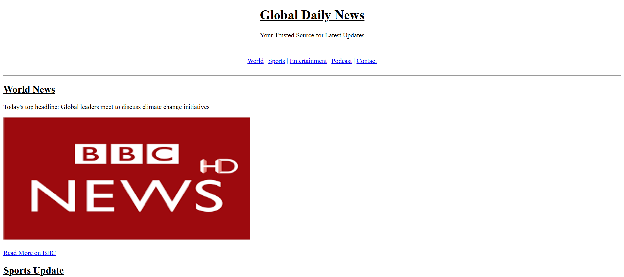
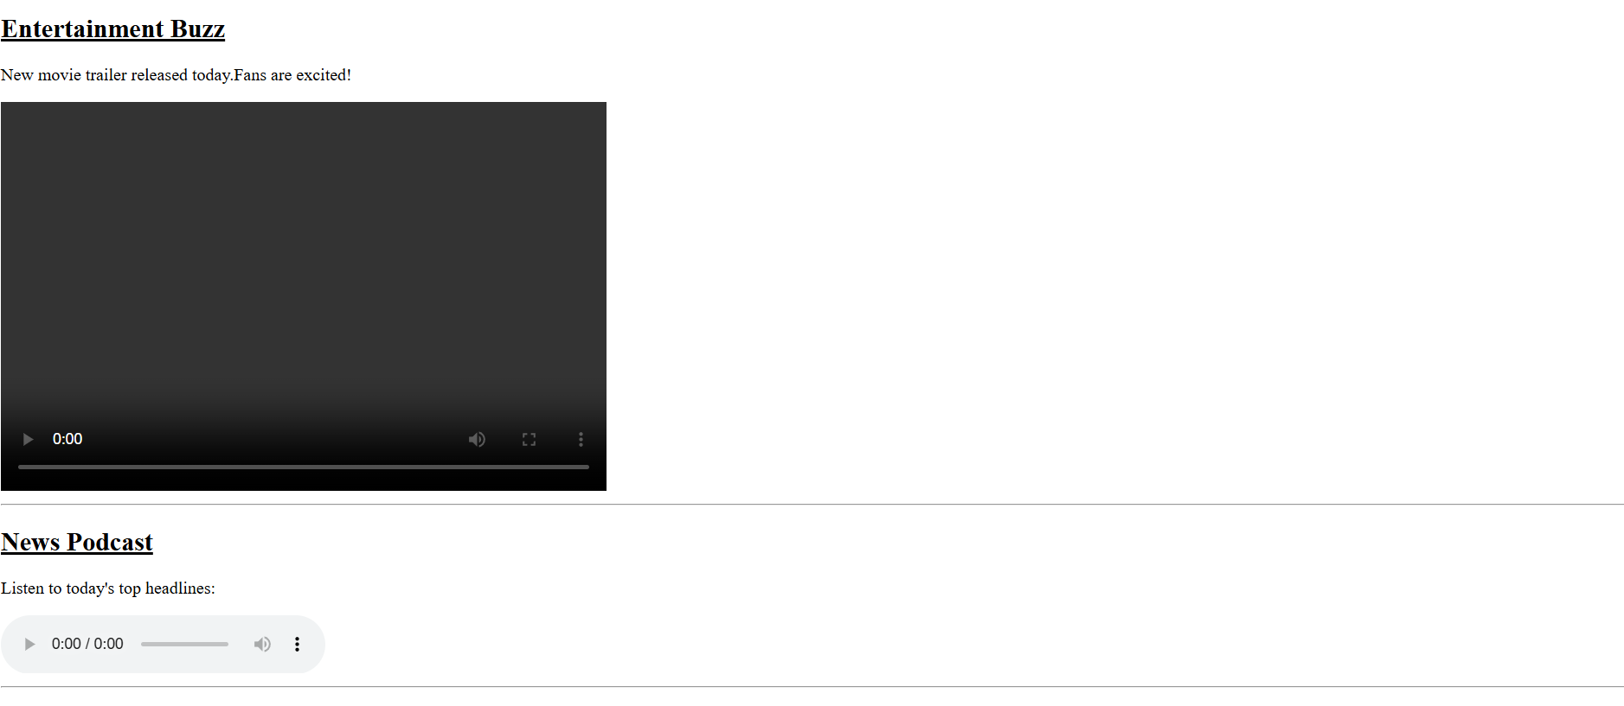
EXPERIMENT 3
<!DOCTYPE html>
<html lang="en">
<head>
<meta charset="UTF-8">
<meta name="viewport" content="width=device-width, initial-scale=1.0">
<title>Document</title>
</head>
<body>
<center><h1><u>EXPERIMENT 3</u></h1></center>
<br><br><br>
<table border="1" cellspacing="0" cellpadding="7" align="center" >
<caption><b>College Timetable - CSE27 Department</b></caption>
<tr>
<th>Day/Time</th>
<th>9:00-10:00</th>
<th>10:00-11:00</th>
<th>11:00-12:00</th>
<th>12:00-1:00</th>
<th>1:00-2:00</th>
<th>2:00-3:00</th>
<th>3:00-4:00</th>
</tr>
<tr>
<th>Monday</th>
<td rowspan="2" align="center">Mathematics</td>
<td align="center">English</td>
<td rowspan="3" align="center">Physics</td>
<td align="center">Break</td>
<td colspan="2" align="center">Computer Lab</td>
<td align="center">Sports</td>
</tr>
<tr>
<th>Tuesday</th>
<td>C Programming</td>
<td align="center">Break</td>
<td colspan="2" align="center">Electronics Lab</td>
<td align="center">Library</td>
</tr>
<tr>
<th>Wednesday</th>
<td align="center">Mathematics</td>
<td align="center">English</td>
<td align="center">Break</td>
<td>Computer Networks</td>
<td colspan="2"><table border="1" cellspacing="0" cellpadding="7" bgcolor="">
<tr cols>
<th colspan="2">Lab Details</th>
</tr>
<tr>
<td>Batch A</td>
<td>DBMS Lab</td>
</tr>
<tr>
<td>Batch B</td>
<td align="center">OS Lab</td>
</table></td>
</tr>
<tr>
<th>Thursday</th>
<td colspan="2" align="center">Workshop</td>
<td align="center">Physics</td>
<td align="center">Break</td>
<td align="center">Mathematics</td>
<td align="center">English</td>
<td align="center">Seminar</td>
</tr>
<tr>
<th>Friday</th>
<td>Computer Networks</td>
<td align="center">English</td>
<td align="center">Physics</td>
<td align="center">Break</td>
<td colspan="3" align="center">Project Work</td>
</tr>
</table>
</body>
</html>
OUTPUT
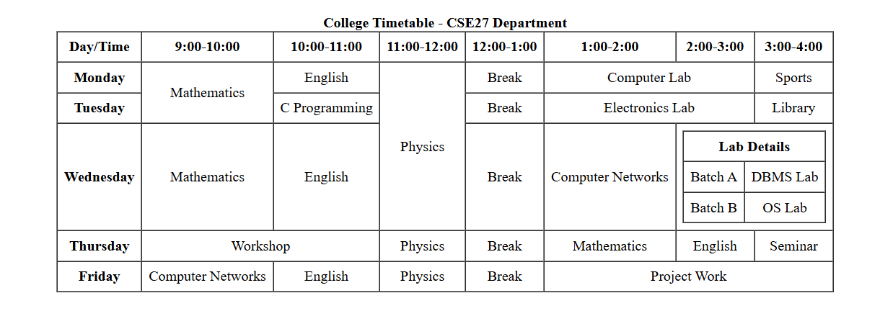

EXPERIMENT 4
<!DOCTYPE html>
<html>
<head>
<title>Hotel Room Booking Form</title>
</head>
<body>
<form border="1" style="width:350px; margin:auto; border:1px solid black; padding:20px;">
<h2 style="text-align:center;">Hotel Room Booking Form</h2>

<label>Full Name:</label><br>
<input type="text" name="fullname"><br><br>

<label>Email:</label><br>
<input type="email" name="email"><br><br>

<label>Phone:</label><br>
<input type="tel" name="phone"><br><br>

<label>Check-in Date:</label><br>
<input type="date" name="checkin"><br><br>

<label>Check-out Date:</label><br>
<input type="date" name="checkout"><br><br>

<label>Room Type:</label><br>
<select name="roomtype">
<option>Single Room</option>
<option>Double Room</option>
<option>Suite</option>
</select><br><br>

<label>Number of Guests:</label><br>
<input type="number" name="guests"><br><br>

<label>Special Requests:</label><br>
<textarea rows="4" cols="35"></textarea><br><br>

<div style="text-align:center;">
<input type="submit" value="Book Now">
<input type="reset" value="Reset Form">
</div>
</form>
</body>
</html>

OUTPUT

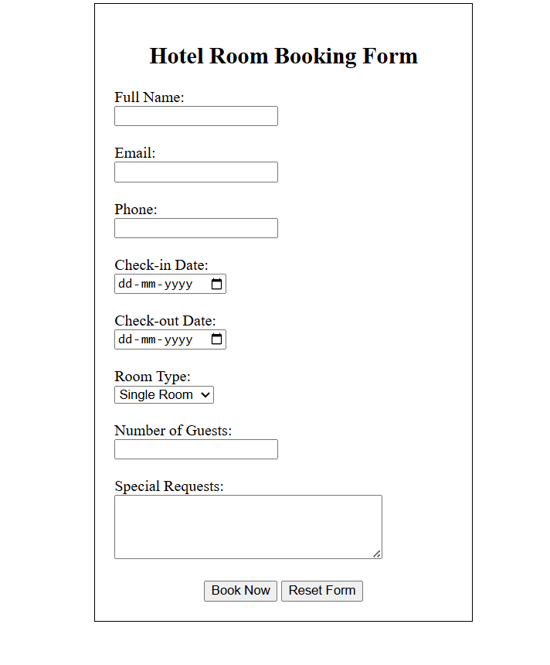

Experiment - 5
<!DOCTYPE html>
<html lang="en">
<head>
<meta charset="UTF-8">
<meta name="viewport" content="width=device-width, initial-scale=1.0">
<title>Student Registration Form</title>
</head>
<body>

<h2 align="center"><u>Student Registration Form</u></h2>

<form method="post" action="/register" align="center">
<table border="0" cellspacing="10" cellpadding="5" align="center">

<tr>
<td align="right">Full Name:</td>
<td><input type="text" name="fullName" placeholder="Enter your full name"></td>
</tr>

<tr>
<td align="right">Email:</td>
<td><input type="email" name="email" placeholder="Enter valid email address"></td>
</tr>

<tr>
<td align="right">Password:</td>
<td><input type="password" name="password" placeholder="Enter password"></td>
</tr>

<tr>
<td align="right">Gender:</td>
<td>
<input type="radio" id="male" name="gender" value="male"> <label for="male">Male</label>
<input type="radio" id="female" name="gender" value="female"> <label for="female">Female</label>
<input type="radio" id="other" name="gender" value="other"> <label for="other">Other</label>
</td>
</tr>

<tr>
<td align="right">Course:</td>
<td>
<select name="course">
<option value="">-- Select Course --</option>
<option value="cs">Computer Science</option>
<option value="ee">Electrical Engineering</option>
<option value="mech">Mechanical Engineering</option>
<option value="civil">Civil Engineering</option>
</select>
</td>
<tr>
<tr>
<td align="right">Contact No:</td>
<td><input type="text" name="contactNo" placeholder="Enter phone number"></td>
</tr>

<tr>
<td align="right" valign="top">Address:</td>
<td><textarea name="address" rows="4" cols="30" placeholder="Enter your address"></textarea></td>
</tr>

<tr>
<td></td> <td>
<input type="submit" value="Register">
<input type="reset" value="Clear">
</td>
</tr>
</table>
</form>

</body>
</html>

output
